Peter Denyer
Dr. Thomas
Penn State

The Illicit Massage Industry: A Study on Socioeconomic and GeopoliticalFactors
Table of Contents

Abstract…………………………………………………………….. pg. 2
Problem/Question……………………………………………… pg. 2-4
Method………………………………………………………………. pg. 4-5
Hypotheses…………………………………………………………. pg. 5
Assumptions…………………………………………………………pg. 5-6
Limitations…………………………………………………………….pg 6
Evaluation……………………………………………………………. pg. 6-8
Findings…………………………………………………………… pg. 8-11
Bibliography………………………………………………………… pg. 12
Annex………………………………………………………………pg. 13-22
Abstract
This study examines the illicit massage businesses (IMBs) in California, Texas, Florida, and New York. It uses spatial data science, optimized Hot Spot Analysis, and Social Network Analysis to answer questions related to localization of IMBs. Location data from The Network, an anti-human trafficking organization that specializes in IMBs, were used in ArcGIS to complete the first question of this project. For the second part of the project, data was manually scrapped from an IMB review site called Rubmaps.ch and analyzed in a Social Network Analysis software called NodeXL. The purpose of this study on socioeconomic and geopolitical phenomena is to determine the localization of IMBs.
Problem
The illicit massage business industry is a sub-set of human trafficking accounting for an approximately five billion dollars per year (The Network, 2023). The Polaris Project, a non-profit organization in charge of handling the National Human Trafficking Hotline, completed a study on their data from December 7, 2007, to December 31, 2016. They concluded that second to Escort Services, the illicit massage, health, & beauty industry accounted for 2,949 out of 16,951 cases of human trafficking and qualified for sex and labor trafficking (Polaris,2017). According to The Network, as of 2023 there are over 13,000 illicit massage businesses operating across all 50 states (The Network, 2023).
While the phenomena of human sex and labor trafficking and IMBs are centuries old, only recently have researchers began to look more closely at the illicit massage industry (IMI). Pioneers in the subject are Vanessa Bouché and Sean Crotty who first investigated the demand of IMBs in Houston, Texas (2017) and locational strategies (2018). While Bouché and Crotty (2017) were successful in using math to estimate the total US revenue the IMI rakes in using Houston as a case study, Bouché and Crotty (2018) develop come up with substantial conclusions regarding locational strategies with the 36 variables used in their second study on Houston.
Like legal businesses such as McDonalds and Starbucks, IMBs and their owners have a localization strategy that has yet to be uncovered. Building off where Bouché and Crotty (2018) end, this study attempts to look at the land-use/socio-economic factor of historically redlined neighborhoods. Historically redlined neighborhoods go back to the 1930s and 40s of the post-Great Depression and have been studied as a systemic factor in many issues seen in the present day. A federal agency called the Home Owners Loan Corporation was tasked with mapping and grading cities and neighborhoods across the country according to “residential security.” By “residential security” what they really meant was making assumptions and predictions of the resident’s ability to pay loans and mortgages. “Best” meant neighborhoods that could make their payments and were colored green and grade A while “hazardous” were colored red and graded D (Nelson et al., 2023). These “hazardous” neighborhoods were declined home improvement loans among other discriminations. This is described and depicted below.
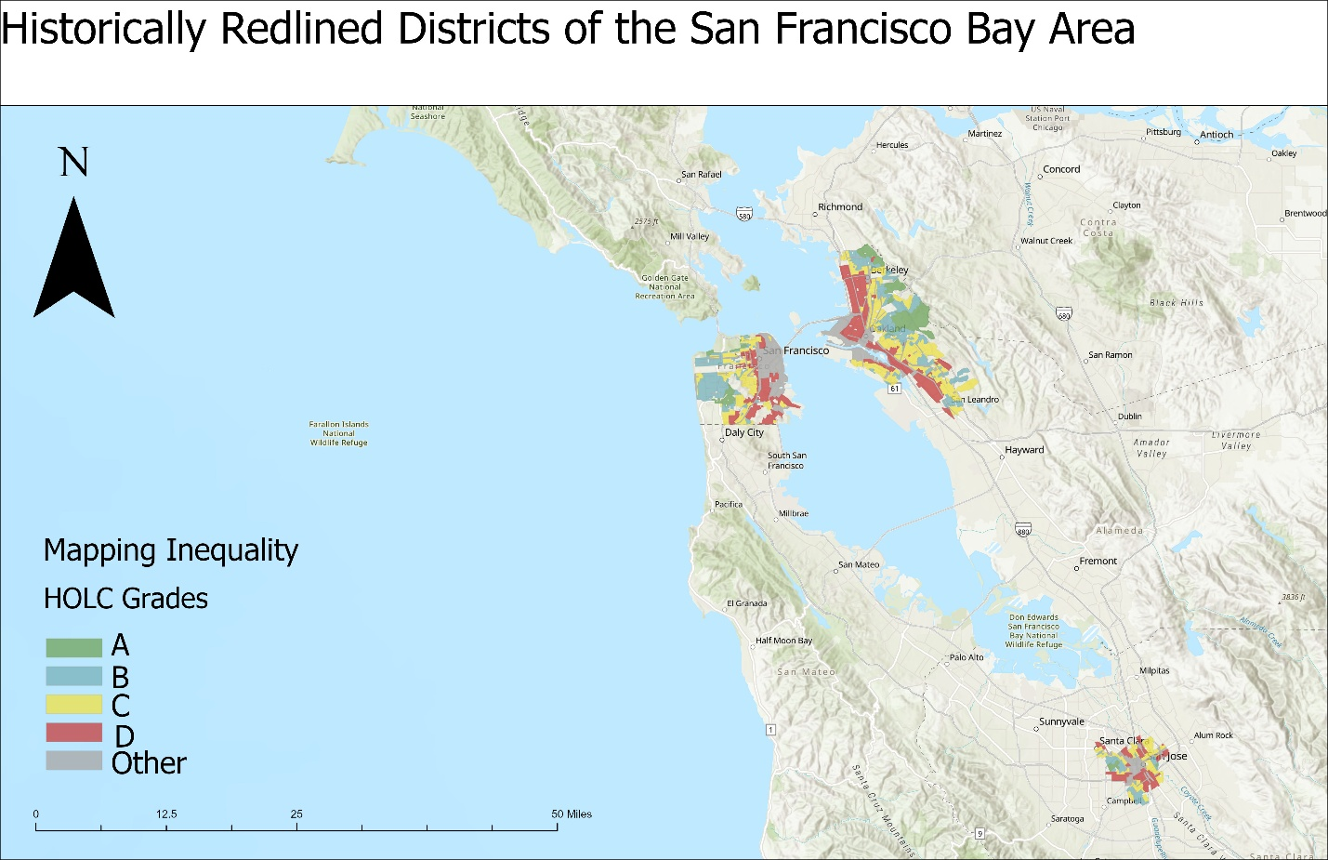
While finding causes that allow these IMBs to operate can be difficult, one answer is to look at the leadership in these cities, counties, and states. By looking at leadership where there is high frequency of IMBs, we can start the conversation of how policies increase or decrease IMBs and see if the IMBs are occuring more frequently in Democratic or Republican congressional districts.
Another problem with the IMI is the clients. Clients drive the demand and promotion for sex trafficking within the IMI on online review sites such as Rubmaps.ch. The clients/reviewers or more commonly known as “Johns” frequent this site and make reviews of the assumed sex worker/masseuse under screennames to avoid detection. This creates a social network within the review site that researchers and law enforcement agencies and officers can study using social network analysis tools. Although a problem exists, the domain of the website is based out of the Czech Republic. Still the “Johns” act with impunity thinking they are above the law and continue to make their reviews of illicit sexual encounters with victims of human trafficking.
Question
With this problem in mind as described above, it led me to come up with the following questions:
Do certain socioeconomic and geopolitical phenomenon make an area conducive to illicit massage businesses in California, Texas. New York, and Florida? Who are the most prolific clients of Illicit Massage Businesses in Santa Clara County, California?
Methods
To answer the first question for the socio-economic factor, I performed spatial data science on a point file in ArcGIS of Illicit Massage Businesses provided by The Network, in California, Texas, Florida, and New York and their cities that were redlined within the polygons of the HOLC. This spatial data science aspect is a quantitative study examining statistics and comparing numbers. The cities in California include Sacramento, Oakland, San Franscisco, San Jose, Stockton, Fresno, Los Angeles and San Deigo. The cities in Texas include Houston, San Antonio, Austin, Dallas, Wichita Falls, and Amarillo. The cities in Florida include Jacksonville, Tampa, and Miami. The cities in New York include New York City, Poughkeepsie, Albany, Schenectady, Utica, Binghamton, Elmira, Rochester, Buffalo, and Niagara Falls.
To answer the geopolitical aspect of the first question, I used the same dataset from The Network in California, Texas, Florida, and New York and performed spatial data science and Optimized Hot Spot Analysis using the census tract as a geospatial unit of analysis. I then overlayed the results with a polygon file of congressional districts of Democratic and Republican congressmen/women from the 119th House of Representatives. This was a mixed methodology combining quantitative and qualitative methods.
For my second question regarding the prolific “Johns” I performed a social network analysis on the review site, Rubmaps.ch. For the Social Network Analysis, I chose Santa Clara County for my site locations because it was my personal “backyard” as I live just one county over and because in my research, I found out that Santa Clara County is one the top three areas in the United States for IMBs. To create the network graph, I “tied” the “Johns” to the suspected sex worker with the business and year of review being additional attributes in a program called NodeXL. My workflow or methodology in choosing the business was a bit random, by choosing the businesses in City of Santa Clara, Milpitas, and San Jose and by choosing the businesses with the most recent reviews on the day of data in-put. Rules I followed in my methodology were: Newest review must be within 1 year, excluded “Reported as NON-E,” and Excluded Massage Parlors with 0 reviews. I added a temporal rule for looking at the reviews from 2015 to 2025 to give me a rich enough dataset to see patterns. In the City of Santa Clara, I looked at the following IMBs: Mio, AV Beauty Spa, Rain Relax Station, and Blue Sky Day Spa. In Milpitas I looked at the following IMBs: Oasis Acupuncture & Spa and Ocean Day Spa, In San Jose I looked at Wellness Health Center, Roman Salon, Urban Beauty, A&Q Skin Care and Lynn’s Beauty.
In-order to get the data in NodeXL, I had to manually copy and paste screennames and sex worker names from Rubmaps.ch to the NodeXL spreadsheet. Sex workers with the same name were given unique names such as cici_2 or coco_4. In my original SNA I had “tied” too many components together. For example, tying cities to IMBs, IMBs to “Johns” and “Johns” to sex worker. This proved difficult to make conclusions and to recognize patterns. By only looking at the “Johns” and sex workers, I could isolate these connections and solve the real question I was looking for, which was who are the most prolific actors in the network? In-order to differentiate the “Johns” and the sex workers, I designated the “Johns” to be solid triangles and the sex workers to be diamonds in the network graph. To highlight the most prolific actors, I ranked the Out-Degree Centrality from greatest to smallest. I then alphabetized the vertex shape so that it would separate the “Johns” from the sex worker. I then changed the size and color of the top ten “Johns” of Out-Degree Centrality. All “Johns” with at least two reviews were designed orange triangles.
Hypotheses
H1: The IMBs will more frequently be located in grade D of HOLC grades.
H2: Congressional district political affiliation influences the presence of IMBs.
H3: A social network analysis will show who the most prolific reviewers of IMBs in Santa Clara County, California.
Assumptions
- I assume that the suspected Illicit Massage Businesses (IMBs) in the dataset provided by the Network are in fact IMBs, given they are listed on Rubmaps.ch and Adultfinder.com, both being review sites for sex work.
- Assuming the locations of the IMBs are accurate, ArcGIS will be able to properly and accurately geocode the Latitude and Longitude coordinates.
- I assume the Latitude and Longitude coordinates are correctly identified suspected IMBs
- Given that the workers are coming from predominantly Asian countries and are given a list of American names on arrival, it can be assumed that workers with the same name are different people working at different businesses.
- Given the nature of the website, it can be assumed that every reviewer or “John” went in with the intent of getting sexual services and received it at the massage parlor.
- Given the sample size of the study, it can be assumed that the top ten prolific “Johns” on the website have reviewed more IMBs than in the actual study as this is habitual behavior.
Limitations
The limitations of this study are that the IMBs are only suspected based on reviews on Rubmaps and AdultSearch, sex buyer review websites, scrapped by the Network’s team. Therefore, in the study this data hasn’t been collaborated in-person and may not always be consistent with what their partners on the ground see and experience. This key limitation is acknowledged in the “read me-data guide” on the first tab of the excel sheet of data of IMBs.
A Limitation of the SNA is action taken after the study. Because Rubmaps is now a foreign domain, “.ch,” it is much harder for local law enforcement to go after or target these serial buyers of sex for arrest. Another limitation of this study is not having a paid subscription to Rubmaps that would allow me to read the explicit or non-explicit reviews and additional comments users can make in reply to the review. It is entirely possible some reviewer made a review of a suspected sex worker only to find out the sex worker denied the buyer of sex and that the review is commenting that happened. If I had a paid subscription, I could make a more complex social network analysis by including the social interaction of the of other users making comments in reply to the original review.
Evaluation
After the spatial data science was completed on the HOLC grades and locations, my first hypothesis that the IMBs would be located more predominantly in Grade D neighborhoods across California, Texas, Florida, and New York was disproved. As the data shows in the analysis, in reality the IMBs are more predominantly located inside Grade C neighborhoods across California, Texas, Florida, and New York.
Within the dataset there were a total of 2,133 IMBs located across California, Texas, Florida, and New York. In total there are 73 IMBs located in the Grade A neighborhoods or about 3% of the total IMBs in the study. In total there are 267 IMBs located in the Grade B neighborhoods or about 13% of the total IMBs in the study. In total there are 750 IMBs located in the Grade C neighborhoods or about 35% of the total IMBs in the study. In total there are 508 IMBs located in the Grade D neighborhoods or about 24% of the total IMBs in the study. In total there are 535 IMBs in the Grade “Other” neighborhoods or about 25% of the total IMBs in the study. Diving deeper into the IMBs located in the Grade C neighborhoods, California accounted for 428 of the 942.
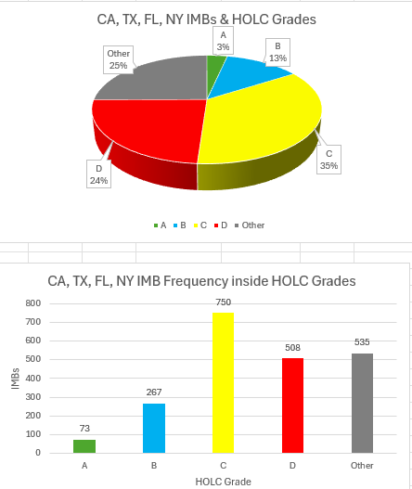

After the spatial data science was completed while evaluating the location of the IMBs and Democratic and Republican congressional districts, it disproved the hypothesis 2. Essentially in more historically and predominantly Democrat states, there are more IMBs in Democrat congressional districts than Republican congressional districts. Vis versa in Republican states, there are more IMBs in Republican congressional districts than Democrat congressional districts. This proves there is not enough evidence to suggest IMBs are more prevalent in either Democrat or Republican congressional Districts. For example, in California a historically and predominantly Democrat State, there are 4,453 IMBs out of 5,346 located in Democrat congressional districts while only 893 in Republican congressional districts. Likewise in Texas, a Republican state, there are 808 IMBs out of 2,417 in Democratic Congressional districts and 1,608 IMBs in Republican congressional districts.
This led me to evaluate the data more by doing a Hot Spot Analysis on the congressional districts and IMBs. This quantitative aspect of the study had mixed results. It also confirmed that IMBs are equally located in Democrat and Republican congressional districts except for New York. New York was the only state not to have any IMBs in Republican congressional districts proving it to be an outlier of the study. However, the Hot Spot Analysis does result in an analytic intelligence product that lists the names of congressmen/women that have hot spots of IMBs within their districts. In California there are a total of 10 hotspots, in Texas there are a total of 9 hotspots, in Florida there are a total of 7 hotspots and in New York there is just one big hotspot.
When evaluating hypotheses 3, the social network analysis confirmed that social network mapping can identify the most prolific reviewers of IMBs. By looking at the Out-degree Centrality or the number of connections that originate at a vertex and point outward to other vertices, the data shows the most influential actors in the network (Hansen et al, 2020).
Findings
Redlined cities and neighborhoods have historic evidence of systemic socio-economic impacts, disadvantages, and inequalities in the present day (Ibsen et al, 2025 & Linde et al, 2023). The first part of the research question wanted to answer whether or not certain socio-economic phenomena make an area more conducive to illicit massage businesses. As the data in the analysis shows, something about the HOLC Grade C neighborhoods is making an area more conductive to IMBs than others. The HOLC Grade C neighborhoods means that the area was “Definitely Declining” which could be a localization strategy for owners or organized crime syndicates to establish themselves. This compares to the hypothesis that the IMBs would be in HOLC grade D or “Hazardous.” This could mean that while Grade D might not have the infrastructure or the economically inclined costumers, the HOLC Grade of a C might have the infrastructure that is needed for a IMB to make profits while staying under the radar of law enforcement. This also compares to Grade A or “Best” and Grade B “Still Desirable” where less IMBs are located. Second to Grade C, IMBs are frequently located inside areas designated as “Other” which signifies Industrial and Commercial.
As described in the evaluation, there does not appear to be any geopolitical phenomena that is making an area conducive to IMB according to this study. This does however point out something significant. That is the issue of illicit massage businesses is or at least should be a bipartisan issue that both Democrats and Republican congressmen should and can work together on defeating or taking down. The one outlier is New York. In New York has one giant hotspot of IMB activity that spans across the metropolitan area of New York City. Something more is happening in this city and state that has yet to be uncovered. Interestingly, of all states, New York is the only state overall with HOLC Grade of D being the highest with 33% of IMBs being in these neighborhoods.
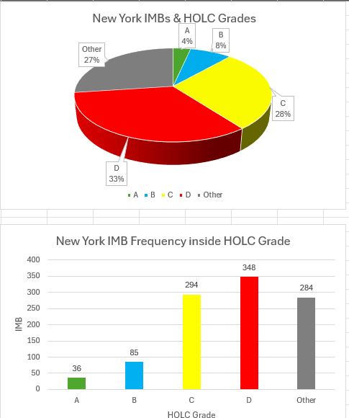

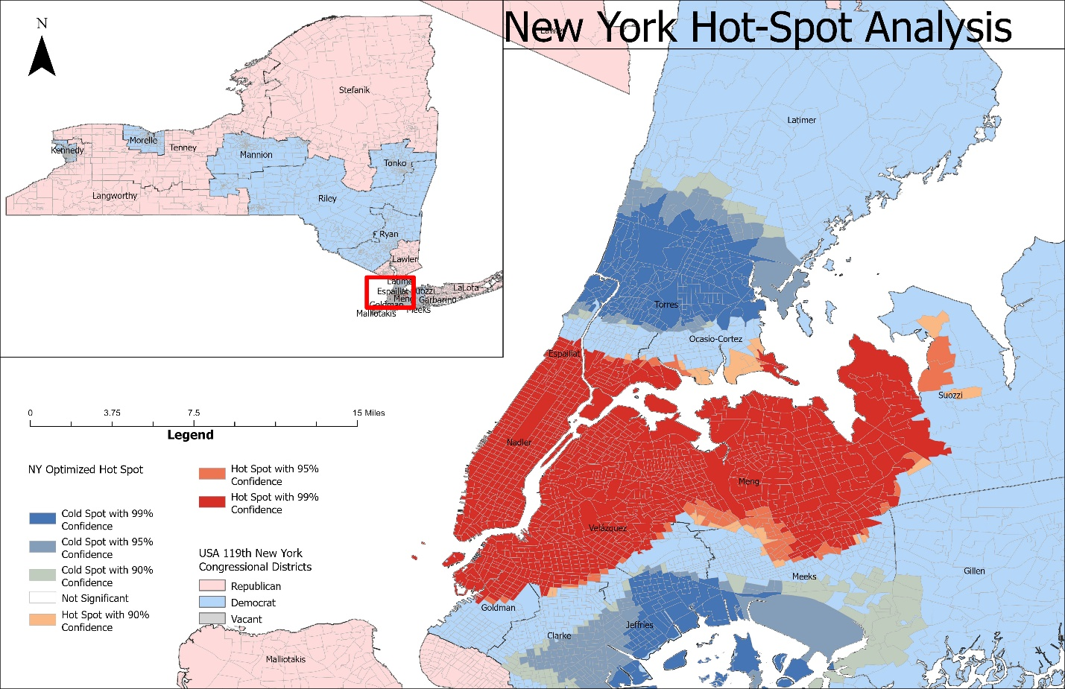
While analysts don’t know the exact identities of the most prolific reviewers of IMBs in Santa Clara, California, analysists do know their screen names, which is a starting point for law enforcement. The Social Network Analysis shows that the most prolific reviewers are: “archer”, “vs2000”, “oldhand”, “massagelover2010”, “largepackage”, “boba13”, “xxoo86”, “clubme115”, “weelstom1”, and “dookiedoo”. These individuals made anywhere from 7 to 3 different reviews about illicit sexual behavior or the attempt of behavior as noted by the limitations in the study. An interesting finding that goes beyond the initial questioning is 59 out of 427 reviewers in the sample had more than one review of a worker. In the network graph below shows this with reviewers being designated as orange triangles.
The intelligence gain through this project is vital to non-governmental organizations, law enforcement and policy makers on capitol hill. Insights shown in figures 6-10 in the annex of this paper show which members of congress have hotspots of IMBs in their congressional districts. With the location intelligence supplied from The Network, these congressmen/women can then target policy and give law enforcement more tools available to them to shut down these illicit massage businesses. Also, with the intelligence gained from looking at IMBs and HOLC redlined neighborhoods, analysts can more accurately predict whether a massage parlor is likely to be illicit in other neighborhoods and cities across the United States. The intelligence from the Social Network Analysis will require high levels of law enforcement and intelligence agencies as the domain for Rubmaps is based out of Czech Republic. However, with the proper warrants, these individuals could be traced and with tools from the congressmen/women they can enact policy to make it illegal to be a sex buyer at IMBs.

Bibliography
Bouche, V & Crotty, S. (2017). Estimating demand for illicit massage businesses in Houston, Texas, Texas. Journal of Human Trafficking, 4(4), 279–297. https://doi.org/10.1080/23322705.2017.1374080
Crotty, S & Bouché, V. (2018). The Red-Light Network: Exploring the Locational Strategies of Illicit Massage Businesses in Houston, Texas. Papers in Applied Geography. 4. 1-23. 10.1080/23754931.2018.1425633.
Hansen, D., Sheneiderman, B., Smith, M., and Himelboim, I. (2020). Analyzing Social Media Networks with NodeXL: Insights from a Connected World 2nd Edition. Ch 3 Social Network Analysis: Measuring, Mapping, and Modeling Collections of Connections. Elsevier Inc.
Ibsen, P. C., Bierbrauer, A., Corro, L. M., Ancona, Z. H., Drummond, M., Bagstad, K. J., & Diffendorfer, J. E. (2025). Land-use and socioeconomic time-series reveal legacy of redlining on present-day gentrification within a growing United States city. PloS one, 20(3), e0317988.
Linde, S., Walker, R. J., Campbell, J. A., & Egede, L. E. (2023). Historic residential redlining and present-day social determinants of health, home evictions, and food insecurity within US neighborhoods. Journal of General Internal Medicine, 38(15), 3321-3328.
Nelson, R. K., Winling, L, et al. (2023). Mapping Inequality: Redlining in New Deal America. Digital Scholarship Lab. https://dsl.richmond.edu/panorama/redlining
The Network. (2023). The IMI at a Glance. https://s3.amazonaws.com/www.thenetworkteam.org/The+IMI+at+a+Glance.pdf
Polaris. (2017). The Typology of Modern Slavey: Defining Sex and Labor Trafficking in the United States. https://polarisproject.org/wp-content/uploads/2017/03/Typology-of-Modern-Slavery-Summary.pdf

Annex
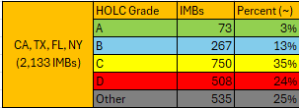
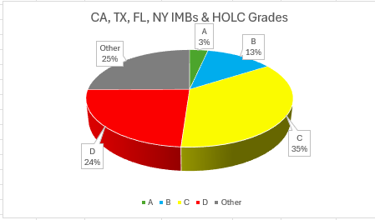
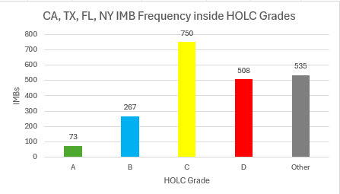
Figure 1
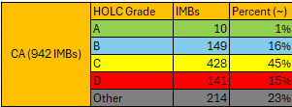

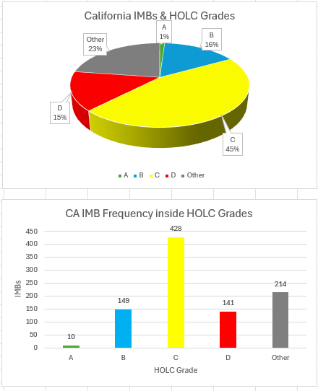
Figure 2
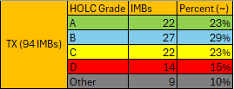
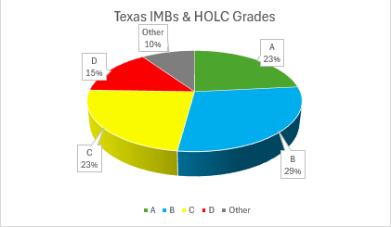
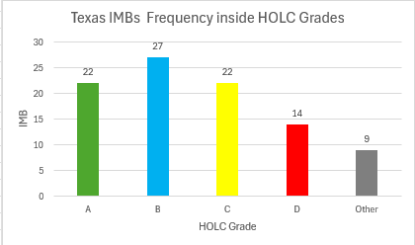
Figure 3
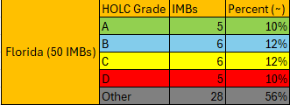
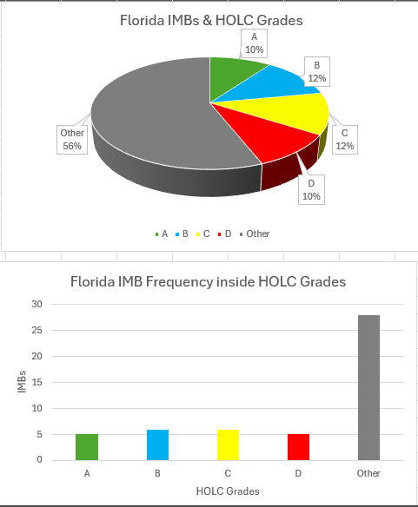
Figure 4
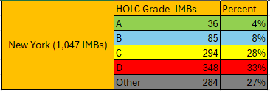
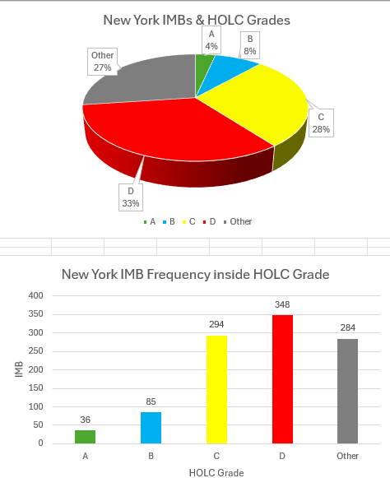
Figure 5

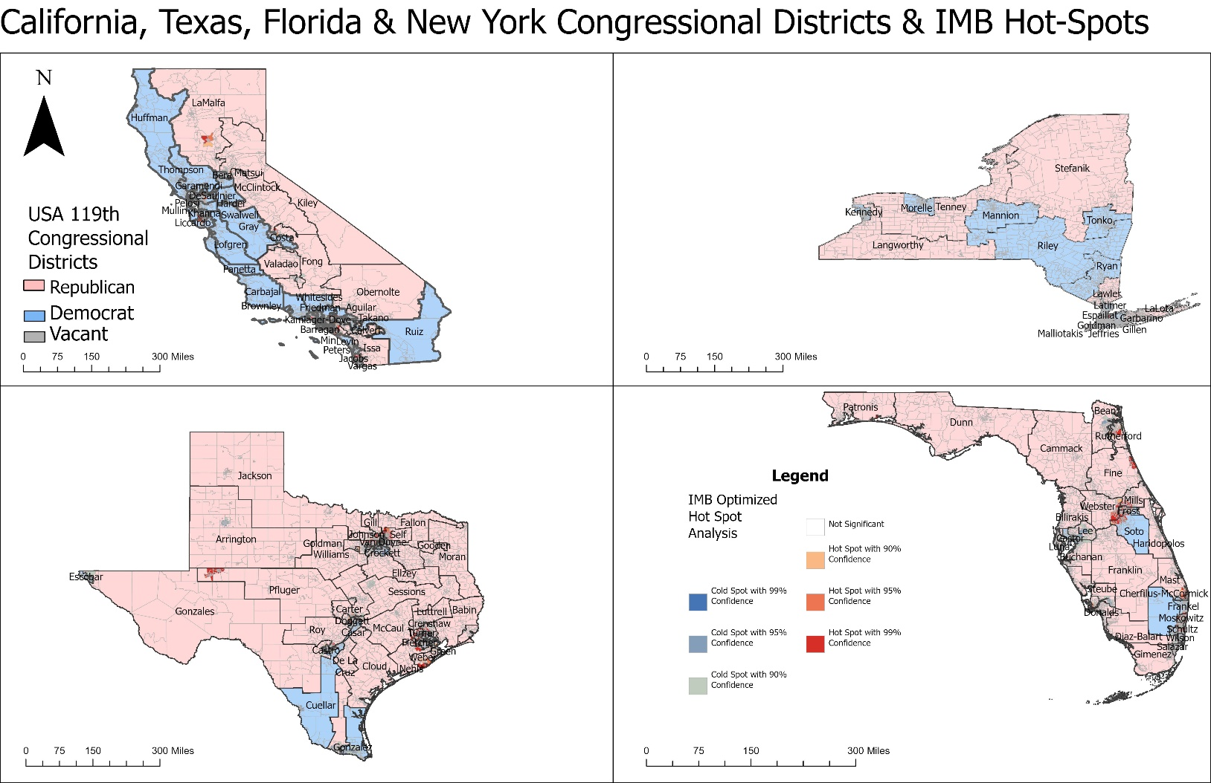
Figure 6
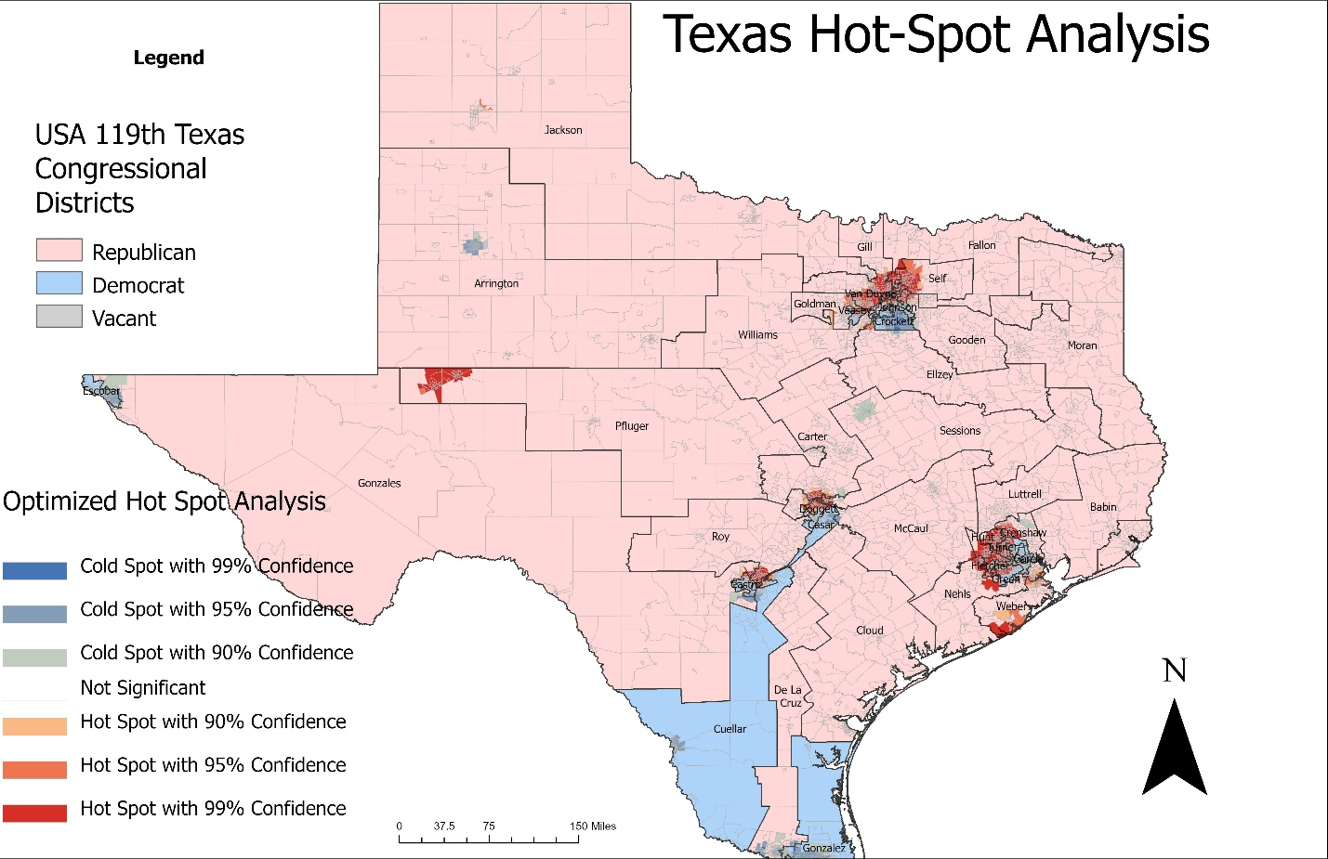
Figure 7
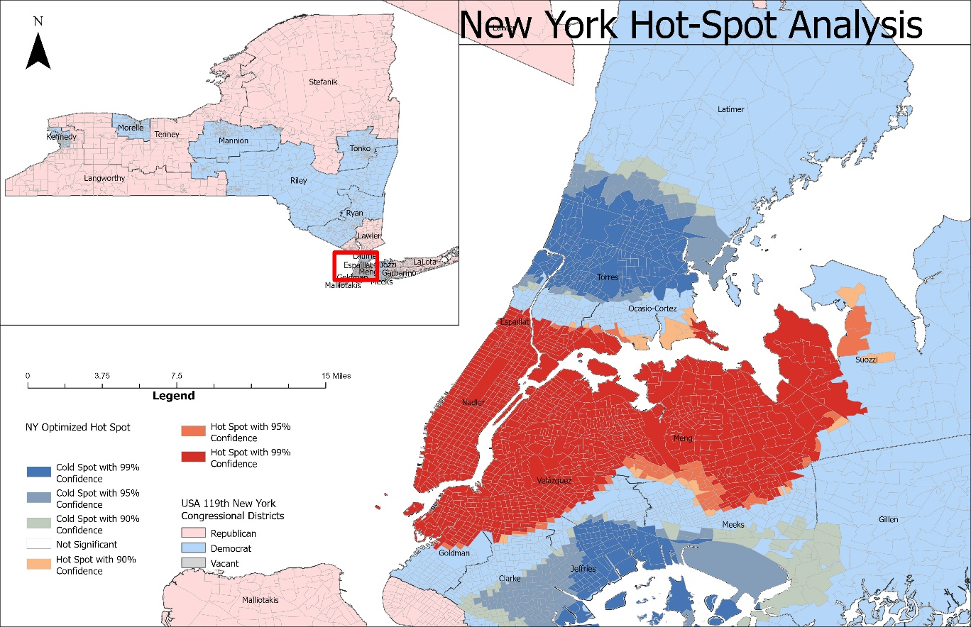Figure 8
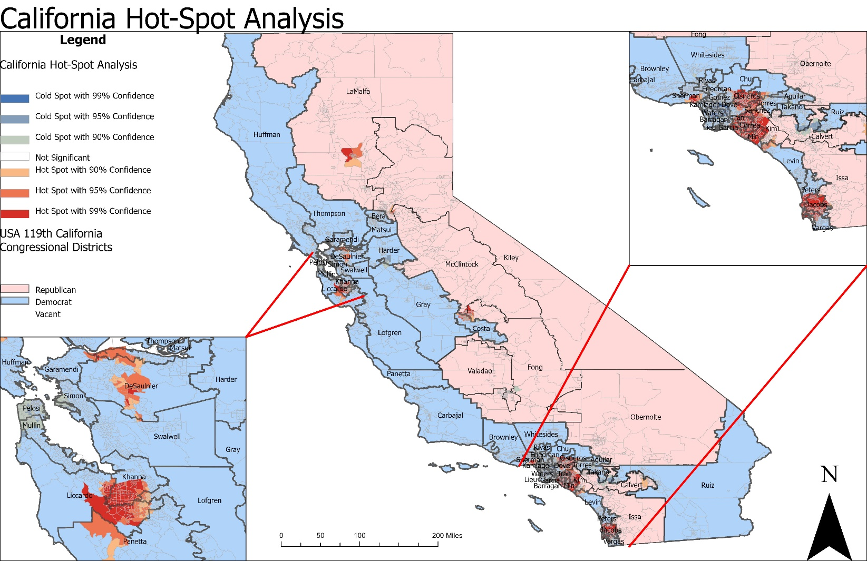
Figure 9

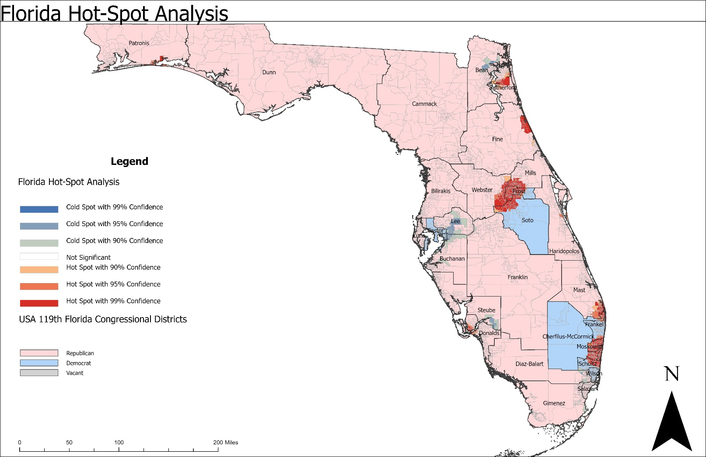
Figure 10

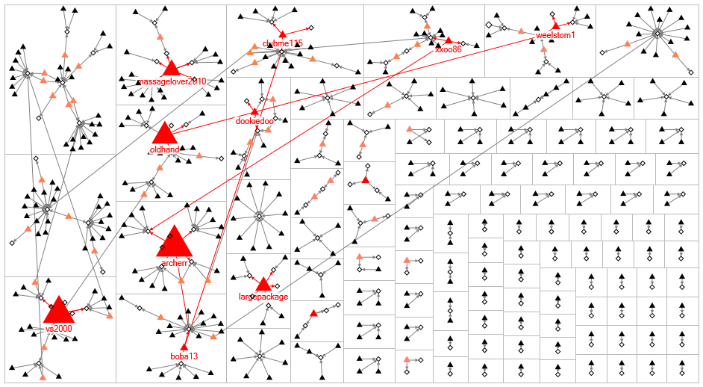
Figure 11

