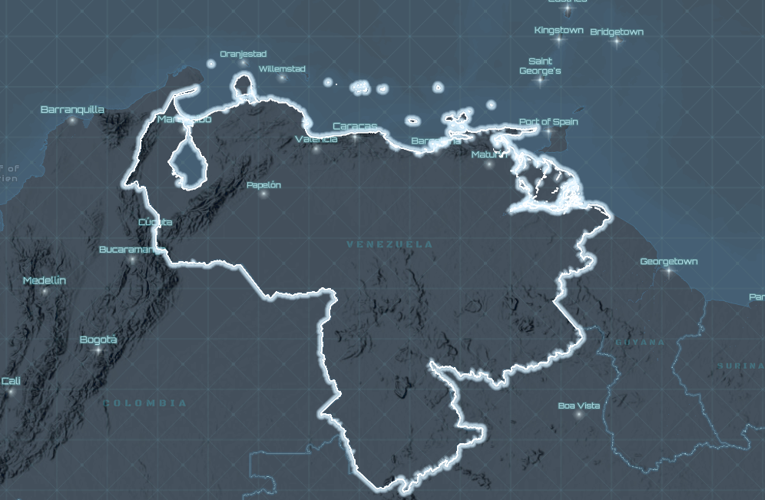  Venezuela as a State sponsor of terrorism | Peter Denyer  Dr. Warner HLS 805

Abstract
This paper explores Venezuelan leaders who continue to support and aid U.S designated Foreign Terrorist Organizations. The purpose of exploring these topics is to evaluate whether or not to designate Venezuela as a State Sponsor of Terror. This paper begins with explaining what and how a country is designated as a State Sponsor of Terror. At the same time, it also sheds light on the discrepancies and flaws of the policy of designating a country as a State Sponsor of Terrorism. Through lens of the actions of Hugo Chavez and Nicolas Maduro, this paper shows their complicity and support for Hezbollah, ELN, FARC and narco-terrorist Cartel of the Suns.
Introduction
With the new War on Drugs initiated by the Second Trump Presidency and the codifying of drug cartels as foreign terrorist organizations and historic ties between Venezuela and other terrorist organizations, there needs to be a policy change on how we view Venezuela. Therefore, this paper seeks to address the following question: Should the United States (US) designate Venezuela a State Sponsor of Terrorism (SST)? It will argue that Venezuela meets the requirements to be added to the SST and will discuss the implications of this designation. With the consequences of the SST designation on the state of Venezuela, it could also be used as an ultimatum to have a regime change to force Dictator Maduro out of office and have him be replaced with a more democratic leaning leader through the process of democratization.
By adding Venezuela to the SST, it will codify and tell the world that under the leadership of Maduro, it is in the same category of Cuba, North Korea, Iran and Syria. Before discussing why Venezuela should be added to the SST, this paper will explain what the SST is, how countries get on the list, and what happens to those countries on the SST list. The designation of State Sponsors of Terrorism is essentially a package of sanctions controlled by the United States State Department and is determined by the Secretary of State. One key aspect of the SST but also controversial and questionable, is that countries must have repeatedly supported acts of international terrorism. What is controversial and questionable is “repeatedly” because it doesn’t give an exact number of occurrences of supporting acts of international terrorism (State Department, nd). It certainly doesn’t mean just once; but does it mean twice, three times, or perhaps four or more times? While that part of the policy is out of the scope of this paper, it sheds light on the ambiguity of the SST that is necessary to address.
Once a country is designated as an SST, sanctions on the country include restrictions on U.S foreign assistance, a ban on defense exports and sales, certain controls over exports of dual use items, miscellaneous financial and other restrictions. In addition to those sanctions, there are also secondary sanctions that penalize persons and countries engaging in certain trade with countries designed as State Sponsors of Terrorism (State Department, n.d). This is a critical secondary part of the SST that will be discussed because of Venezuelan second largest trading partner after the United States, China (OEC, 2023).
Venezuela and the Maduro regime should be designated a State Sponsor of Terrorism for Maduro’s complicity, support, and sanctuary for Hezbollah, National Liberation Army (ELN), the Revolutionary Armed Forces of Colombia (FARC), Cartel de los Soles (Cartel of the Suns) (Young, 2024 & Cano, 2025). Certainly, with this plethora of examples that will be explored in the literature review, Venezuela has met the requirements of “repeatedly” supporting terrorism and should be designated as a State Sponsor of Terrorism.

Lit Review
Muravchik poses that the continued presence of a dictatorship, helps terrorist groups form and flourish and that’s exactly what has happened in Venezuela (1-Warner, 2025). This paper assumes the reader believes Venezuela is in fact a dictatorship and therefor will not flesh out the prescriptions of dictatorship as to not drive away from the presented topic of State Sponsorship of Terrorism.
The Venezuelan government has long standing ties with Hezbollah, an Iranian proxy and terrorist organization across the Chavez and Maduro regimes that has allowed it to operate freely in the country (Giambertoni, 2025). While few there are few unclassified and open-sourced literature on the Venezuela-Hezbollah nexus some information is available. For example, Hezbollah activity in Venezuela includes drug trafficking, money laundering, and illicit smuggling (Giambertoni, 2025 & Clarke, 2019). In 2008, the US Department of the Treasury sanctioned two Venezuelans, Ghazi Nasr al Din and Fawzi Kan'an for support of Hezbollah (1-U.S Department of the Treasury, 2008). The importance of the sanctioning of Nasr al Din, was the fact that he was a Venezuelan diplomat and used his position to facilitate travel of two members of Hezbollah to and from Venezuela (US Department of the Treasury, 2008). Even more interestingly at the government level, Venezuela refuses to label Hezbollah as a terrorist organization (Giambertoni, 2025).
The regimes of Chavez and Maduro also have had ties with the ELN. The ELN was designated as a foreign terrorist organization in October 1997 (DNI, n.d). While it traditionally operates in Colombia, recently it has been expanding in Venezuela acting as an “paramilitary force supporting the government of Nicolas Maduro” (Insight Crime, 2024). The ELN’s history in Venezuela spans back to 1973 where they sought refuge after a series of defeats in Colombia and were welcomed by Chavez with open arms (Insight Crime, 2024). While Chavez was in power in 2002 and 2004, the Venezuelan military allegedly supplied ELN with weapons and munitions and other assistance (Rojas & Walther, 2022).
Later during their rebuilding phase, the ELN became “involved in illegal mining with the blessing of military and political sectors loyal to Maduro” (Insight Crime, 2024). Geographically, ELN has presence in Zulia, Tachira, Apure, and the Amazonas states of Venezuela (Insight Crime, 2024). Within these states, the ELN control multimillion dollar criminal interests such as drug trafficking, illegal mining, smuggling, and extortion (UCDP, 2023). These ventures are only permissible with the help of the Maduro government who allow them to freely operate in their country. Most recently, according to Human Rights Watch, ELN and Venezuelan military were fighting against ex-FARC (Rojas & Walther, 2022). Moreover, “ELN has repeatedly stated its commitment to defending the Venezuelan regime and its president from foreign intervention and/or local insurrection” (Rojas & Walther, 2022). With this in mind, its clear that Venezuela has repeatedly supported the ELN which supports the claim the Venezuela should be designed as a State Sponsor of Terrorism.
Like the ELN, we have seen both the Chavez and Maduro regimes support Fuerzas Armadas Revolucionarias de Colombia (FARC) (Byman, 2008; Boersner, 2020). While Venezuela is not considered an SST as of December 2025, it has been designated as a state “not fully cooperating” in the fight against terrorism. As Frank Urbanic, a U.S. Department of State official claims “Venezuela demonstrated a near complete lack of cooperation with U.S Government efforts to fight terrorism” (Byman, 2008). If intelligence is correct and is not just rumor intelligence (RUMINT), as Colombian intel suggests the Chavez government was actively funding FARC (Byman, 2008). This serves as an example of a state leader providing constituency support as outlined in the third level of Sanchez-Cuenca (2007) scale of rebellious behavior (2-Warner, 2025). Jeferson (2020) goes as far as claiming that FARC looked up to Chavez as their “ideological mentor and official sponsor.” According to the indictment on Maduro authored by U.S Attorney General William Barr, it explains in detail how during the Chavez regime, Chavez supported FARC by using funds from Venezuelan state oil company (PDVSA) (Jeferson, 2020). With intelligence gathered after the 2008 killing of senior FARC commander Raul Reyes, it was discovered that Chavez and other officials used “FARC money to fund electoral campaigns in the region” (Farah, 2020).
After Chavez transferred power to Maduro, he also instructed him to continue his relationship with FARC. Maduro welcomed the entry of former FARC leaders as Ivan Marquez and Jesus Santrich following their renewed armed struggle in 2019 (Rojas & Walther, 2022). In 2019 and 2020, FARC established multiple military bases in Venezuela along the border with the help from the Venezuelan Army allowing them to grow support (Jeferson, 2020). Also, in the indictment by Barr, FARC paid bribes that allowed FARC to traffic drugs which benefited Maduro, other Venezuelan leaders and intelligence officials (Jeferson, 2020).
Venezuela’s and Maduro’s most recent association and support of terrorism stems from the recently designated Foreign Terrorist Organizations, Cartel de los Soles (Cartel of the Suns), Tren de Aragua and the Sinaloa Cartel. The designation of a drug cartel is a formal recognition of the mitosis of the crime-terror nexus (3-Warner, 2025). According to the U.S Treasury, Maduro is the head of Cartel of the Suns and other high ranking officials in the military, intelligence and legislature assist in supporting Cartel of the Suns (2-U.S Department of the Treasury, 2025). If true, this its just yet another example on how Maduro and the Venezuelan government is supporting terrorism and yet another example on why Venezuela should be designated a State Sponsor of Terrorism.
Analysis
Using open-sourced intelligence and academic literature this paper described how Venezuela under both Chavez and current leadership of Maduro as well as other apparatuses of the government are complicit in repeatedly supporting and/or aiding terrorist groups designated by the United States. While there are pros of designating Venezuela a State Sponsor of Terrorism, there are cons in this policy decision as well. In the following analysis, the paper will highlight and compare and contrast this monumental decision.
Since Maduro has been already designated as a Foreign Terrorist as the leader of Cartel of the Suns, the logical next step in putting pressure on his regime would be to designated Venezuela as a State Sponsor of Terrorism. By designating Venezuela as an SST, it will ban defense exports and sales which has a larger effect on the War on Terror as Iran uses Venezuela through its proxy, Hezbollah to equip and fund terrorists. Also, by designating Venezuela as an SST it will lead to heightened controls over dual-use items which can include advanced technology and chemicals, these chemicals could be precursors for illicit drugs. By designating Venezuela an SST, it will help legally justify U.S military strikes on narco-terrorist, ELN or FARC bases or areas of operation as a counter terrorism operation.
A flaw in designating a country as a State Sponsor of Terror lies deep in the disconnect in policy consensus of what counts as state sponsorship among U.S and its allies (Byman, 2008). A con of putting Venezuela on the SST list is once a country is on it, it is hard to remove even if it does not support terrorism, a case study on this would be Sudan (Byman, 2008). So, if there ever was change of leadership in Venezuela, be it more pro counter terrorism/narco-terrorism and actively engaged with the U.S it would be difficult for it to come off the SST list. Another con with adding Venezuela to the SST list is despite our ongoing conflicts, the U.S is Venezuela’s biggest trading partners with approximately $11.9 billion for exports and $6.0 billion in imports in 2024 (Office of the United State Trade Representative, 2025). With the SST designation, we would not be able to trade with Venezuela. One of the biggest blow backs of designating Venezuela as an SST is that it could justify the U.S to strike Venezuela directly which Byman (2008) argues, “leads a state to escalate its backing of terrorism and can simultaneously help that regime consolidate its domestic power.”
Policy
With this literature review and analysis in mind, Venezuela should be designated a State Sponsor of Terrorism. An alternative policy decision could be to use the designation as a tool for leverage to institute a peaceful regime change in Venezuela. While both these policy changes won’t end terrorism or narco-terrorism in Venezuela, it’s a step in the right direction and gives the U.S government more tools to legally fight terrorism in the country. As Connable and Libicki (2025) suggest “sanctuary is vital to insurgencies” and that “withdrawal of state sponsorship cripples an insurgency and typically leads to its defeat” (4-Warner, 2025). By replacing Maduro through leverage of an SST designation with a new leader who is against ELN, FARC, and Cartel of the Suns would gradually defeat terrorism in Venezuela. For the first time we could see active participation in counter terrorism operations conducted in tandem with the U.S. If all else fails designating Venezuela a SST will make it harder for Venezuela to trade with the world and will cripple the country, which could result in Maduro being toppled from power.

Bibliography
Boersner, A. (2020). Venezuela 2019: A tale of two presidents: Venezuela 2019: Un relato de dos presidentes. Revista De Ciencia Política (Santiago), 40(2), 539. https://doi.org/10.4067/S0718-090X2020005000118
Byman, D. (2008). The Changing Nature of State Sponsorship of Terrorism. The Saben Center for Middle East Policy at the Brookings Institution. Retrieved from: https://psu.instructure.com/courses/2419625/pages/l06-state-sponsored-terrorism?module_item_id=45105539
Cano, R. (2025). US labels Maduro-tied Cartel de los Soles as a terror organization. It’s not a cartel per se. https://www.msn.com/en-us/politics/government/us-set-to-label-maduro-tied-cartel-de-los-soles-as-a-terror-organization-it-s-not-a-cartel-per-se/ar-AA1R1jQx?ocid=BingNewsSerp
Clarke, C. (2019). Hezbollah Is in Venezuela to Stay. RAND. https://www.rand.org/pubs/commentary/2019/02/hezbollah-is-in-venezuela-to-stay.html
DNI. (n.d). Counter Terrorism Guide: National Liberation Army (ELN). https://www.dni.gov/nctc/terrorist_groups/eln.html
Farah, D. (2020). The Maduro Regime’s Illicit Activities: A Threat to Democracy in Venezuala and Secuirty in Latin America. Atlantic Council. https://www.atlanticcouncil.org/wp-content/uploads/2020/08/The-Maduro-Regime-Illicit-Activities-A-Threat-to-Democracy-in-Venezuela-and-Security-in-Latin-America-Final.pdf
Giambertoni, M. (2025). Hezbollah’s Networks in Latin America: Potential Implications for U.S Policy and Research. RAND. https://www.rand.org/pubs/perspectives/PEA3585-1.html
Insight Crime. (2024). National Liberation Army (ELN). https://insightcrime.org/colombia-organized-crime-news/eln-profile/
Jeferson, G. P. (2020). FARC-hezbollah: The success of venezuela-iran proxy groups and their convergence in the americas. Security and Defence Quarterly, 31(4), 117-134. https://doi.org/10.35467/sdq/130934
1-U.S Department of the Treasury. (2008). Treasury Targets Hizballah in Venezuela. https://home.treasury.gov/news/press-releases/hp1036
2-U.S Department of the Treasury. (2025). Treasury Sanctions Venezuelan Cartel Headed by Maduro. https://home.treasury.gov/news/press-releases/sb0207
UCDP. (2023). Venezuela. https://ucdp.uu.se/country/101
Office of the United States Trade Representative. (2025). Venezuela Trade summary. https://ustr.gov/countries-regions/americas/venezuela
OEC. (2023). Venezuela. https://oec.world/en/profile/country/ven
State Department. (n.d). State Sponsors of Terrorism. https://www.state.gov/state-sponsors-of-terrorism/
Rojas, J.D., & Walther, O.J. (2022). Revolutionary Insurgents or Conservative Reactionaries? National Liberation Army's Transnational Expansion in Colombia and Venezuela. Journal of Latin American Geography 21(2), 6-33. https://dx.doi.org/10.1353/lag.2022.0019.
Young, B. (2024). It’s Time to Designate Venezuela as a State Sponsor of Terrorism. RAND. https://www.rand.org/pubs/commentary/2024/08/its-time-to-designate-venezuela-as-a-state-sponsor.html
1-Warner, J. (2025). L13 Counter Insurgency. Penn State University. https://psu.instructure.com/courses/2419625/pages/l13-overview?module_item_id=45105602
2-Warner, J. (2025). L6 Gaining Capability I: Patronage. Penn State University. https://psu.instructure.com/courses/2419625/pages/l06-overview?module_item_id=45105532
3-Warner, J. (2025). L8 Gaining Capability III: Financing Insurgency. Penn State University. https://psu.instructure.com/courses/2419625/pages/l08-overview?module_item_id=45105554
4-Warner, J. (2025). L14 Ending Insurgency. Penn State University. https://psu.instructure.com/courses/2419625/pages/l14-overview?module_item_id=45105610

